**On the importance of respecting the template**

**Name F.1**, Name F.2 & Name F.1

*1University of your dreams, somewhere 2University of your dreams either, somewhere*

*[firstname.lastname@univ-dreams.com](mailto:firstname.lastname@univ-dreams.com)*

Respecting the template is an excellent way of earning the respect of your peers, recognizing that a proper template facilitates the editing and post-processing of your scientific output. It also has the excellent property of being easy to make and saving you time.

To deal with this problem correctly, there are two possible solutions: firstly, use the file you're reading and edit it as you wish, respecting the following rules, which are the same for all: 1 page, arial 10, and 1 figure maximum. References should be formatted according to the model below, using abbreviated journal names. Secondly, use the .tex template provided on the conference website.

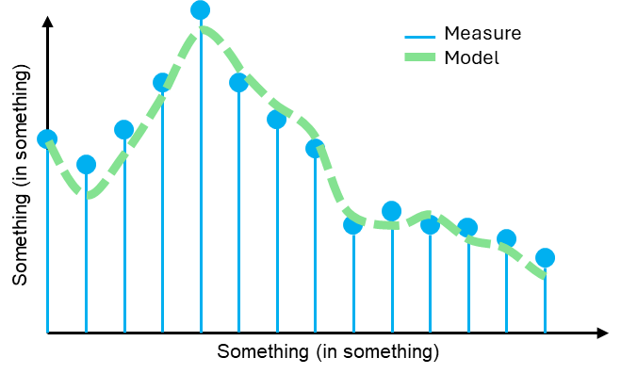

*Arguably one of the best template figures in the world.*

After that, all the lights should be on to highlight the scientific quintessence of your work and shine in the eyes of the world, all in a format that meets the expectations of your favorite scientific committee.

**References**

[1] Fun I., Wonderfu L. & Astonishin G., Int. J. of Temp.,12, 25-50 (2024)

[2] Incredi B. & Excentri C., Temp. & Conf., 27, 12-18, (2023)